**Anaesthetised Cat Simulation**

**Notes for Instructors**

**(c) John Dempster, 2024**

Contents

Adrenoceptor Agonists 2

Adrenoceptor Antagonists 3

Muscarinic Cholinergic Transmission at the Heart 4

Nicotinic Cholinergic Neurotransmission at Skeletal Muscle (1) 5

Nicotinic Cholinergic Neurotransmission at Skeletal Muscle (2) 6

## Adrenoceptor Agonists

**The effects of 5 µg/kg doses of noradrenaline, adrenaline and isoprenaline are shown below.**

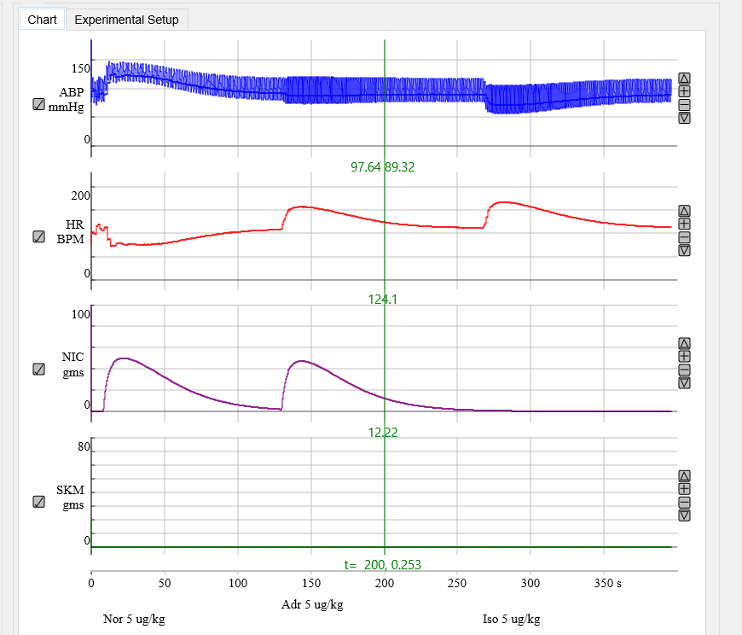

**Noradrenaline produces an increase in both systolic, mean and diastolic B.P. and a decrease in heart rate. It is an agonist at both α- and β-adrenoceptors with a greater potency for α- adrenoceptors. It causes vasoconstriction by α-adr. mediated constriction (outweighing β-adr. dilation of blood vessels), raising mean B.P. The paradoxical reduction in heart rate is caused by the centrally mediated baroreceptor feedback mechanism acting to reduce heart rate, via increased parasympathetic (and reduced sympathetic) drive to the heart**

**Adrenaline produces a small increase in systolic and a decrease in diastolic B.P., little change in mean B.P., and an increase in heart rate. It is an agonist at both α- and β-adrenoceptors with an approximately equal potency. It increases heart rate, contractile force and cardiac output, pumping more blood into the arterial system (increasing systolic B.P.). It causes vasodilation by β -adr. mediated dilation of blood vessels outweighing α-adr. mediated constriction (reducing diastolic B.P.). Effects balance out leaving little change in mean B.P. and consequently β -adr. mediated increases in heart rate are now visible because baroreceptor feedback is not acting.**

## Adrenoceptor Antagonists

**The effects of 2 mg/kg phentolamine (α-adr. antagonist) and 2 mg/kg propanalol (β -adr. antagonist) on applications of 5 µg/kg adrenaline.**

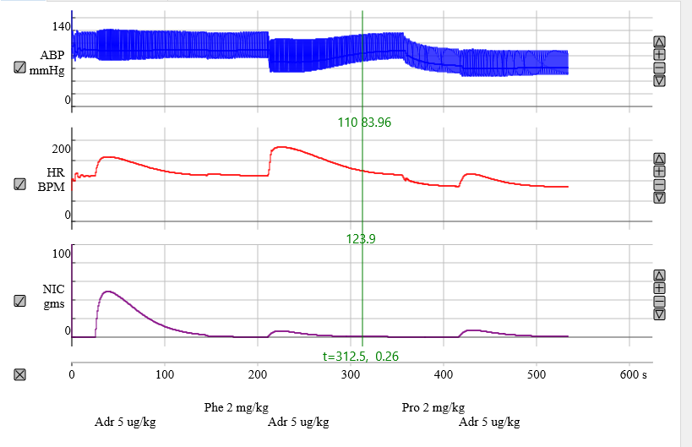

**Phentolamine, by blocking α-adr. mediated vasoconstriction) converts the B.P. response to adrenaline from increased B.P. sys / decreased B.P. to a decrease in both (similar to effects of isoprenaline). Heart rate is increased because the adrenaline’s β -adr. activity is unaffected AND baroreceptor feedback is acting to boost H.R. because of the reduction in mean B.P.**

**Addition of propananol then blocks the β -adrenoceptors reducing the heart rate response to adrenaline and blood pressure largely unresponsive to the addition of adrenaline. Mean blood pressure is left reduced relative to control demonstrating the antihypertensive effects of adrenoceptor antagonists.**

## Muscarinic Cholinergic Transmission at the Heart

**With the vagus nerve being stimulated, 2 µg/kg acetylcholine is added, then 5 mg/mg atropine, then 2 µg/kg acetylcholine again.**

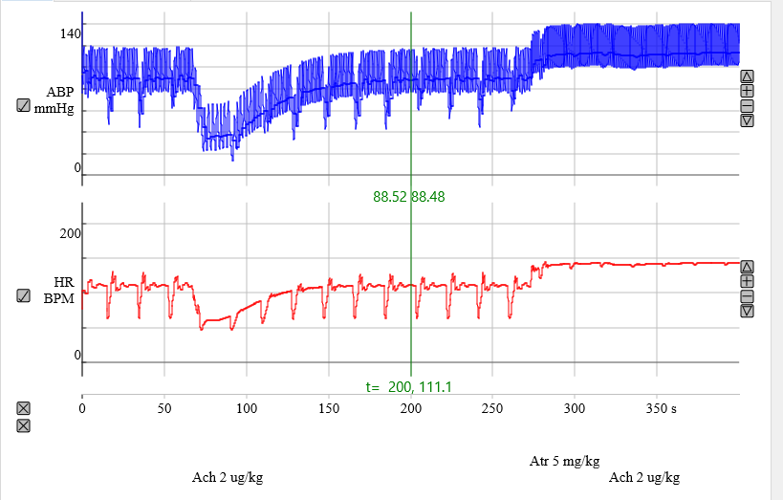

**Vagal stimulation results in a brief depression of heart rate and blood pressure and Ach produces a similar but larger and more long last depression. After addition of atropine, both the vagal and Ach responses are abolished, indicating that atropine acts as an antagonist of the muscarinic Ach receptors on the heart.**

## Nicotinic Cholinergic Neurotransmission at Skeletal Muscle (1)

**With stimulation of the vagal, sup. Cervical and Tibialis Anterior skeletal muscle nerves on, 1 mg vecuronium is added, followed by 50 µg/kg of neostigmine, then 5 mg atropine.**

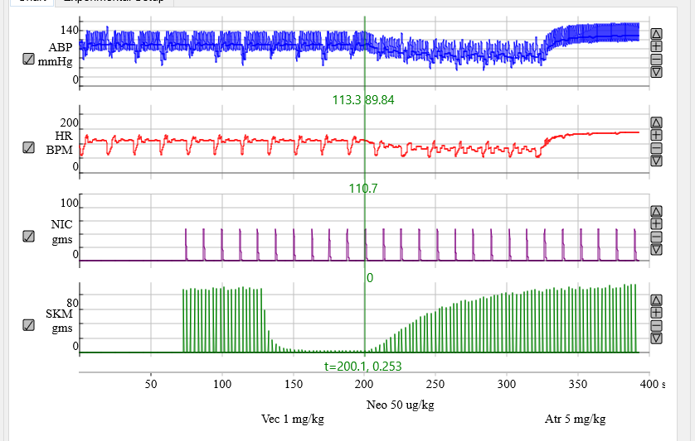

**Vecuronium (a competitive nicotinic cholinoceptor antagonist at the neuromuscular junction) almost completely abolishes the skeletal muscle contractions. Addition of neostigmine (a cholinesterase inhibitor) reverses this block. Note that it also results in a decrease in heart rate and B.P. (caused by inhibition of cholinesterase and an enhancement of Ach activity at the heart). This effect can be blocked by addition of atropine (as would be routine practice in a medical operation).**

## Nicotinic Cholinergic Neurotransmission at Skeletal Muscle (2)

**With stimulation of the vagal, sup. Cervical and Tibialis Anterior skeletal muscle nerves on, 100 µg/kg suxemethonium is added, followed by 50 µg/kg of neostigmine.**

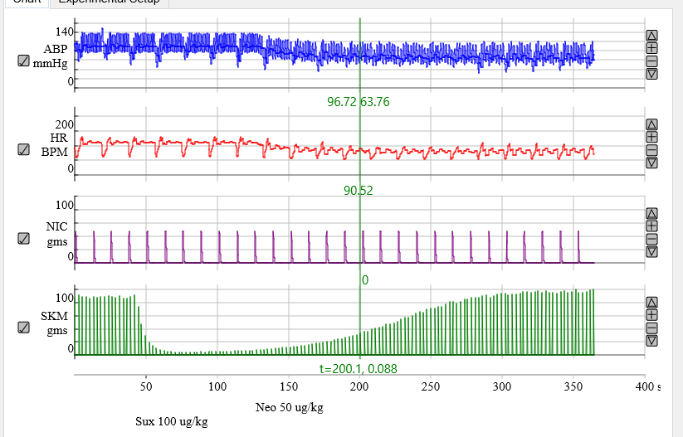

**Suxemethonium (a non-competitive, depolarizing, nicotinic cholinoceptor antagonist) almost completely abolishes the skeletal muscle contractions. Addition of neostigmine (a cholinesterase inhibitor) fails to reverses this block. However, suxemethonium is fast acting and reversing, leading to a rapid recovery (compared to vecuronium).**